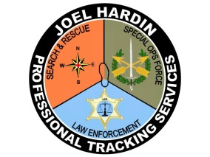
Tracking Step by Step... Joel Hardin Professional Tracking Services
225 Mill Road, Clearwater, Idaho 83552-5116 208-926-4390 joel@ jhardin-inc.com www.jhardin-inc.com
Phone: (360)966-7707
Email: Joel@jhardin-inc.com

TRAINING COURSE REGISTRATION

Course Applicant: Please complete this form and send via email attachment or regular mail to: jsciacca@larimercountysar.com or LCSAR- c/o – Joe Sciacca 3651 Little Dipper Drive, Fort Collins, Co. 80528.
Course Location: | Buckhorn Methodist Camp, west of Fort Collins, CO.
Course Date: | September 18th - 20th, 2015
Course Name: | Tracking
Student Name:
Mailing Address:
City:
Prov/State: | _________________ Zip Code/Postal ode:__________________
Phone #: | ( ) ______________ Group/Unit/County:_________________
E-Mail Address: | ________________________________________________________
Current JHPTS Certification | (please check one) (you may double click on the appropriate square and change the default value from Not Checked to Checked)
New Student | Basic Tracker | Apprentice Tracker
Journeyman Tracker |  | Sign Cutter
Deposit Enclosed | $100.00_______ Tuition Fee Enclosed $____________
Accommodations: If accommodations are provided for this class please check the appropriate box.
I will utilize: Bunk Room RV Parking Place Tent Camping Spot
Applicant: Please note any requests, dietary needs or questions that you have and wish a response from the contact person.
____________________________________________________________________________________________________________________________________________________________________________________________________________________________________________________________________________________________________________________________________________________________________________

